**Docs 1 React-js**

**Create a new React Application with the name “myfirstreact”, Run the application to print “welcome to the first session of React” as heading of that page**

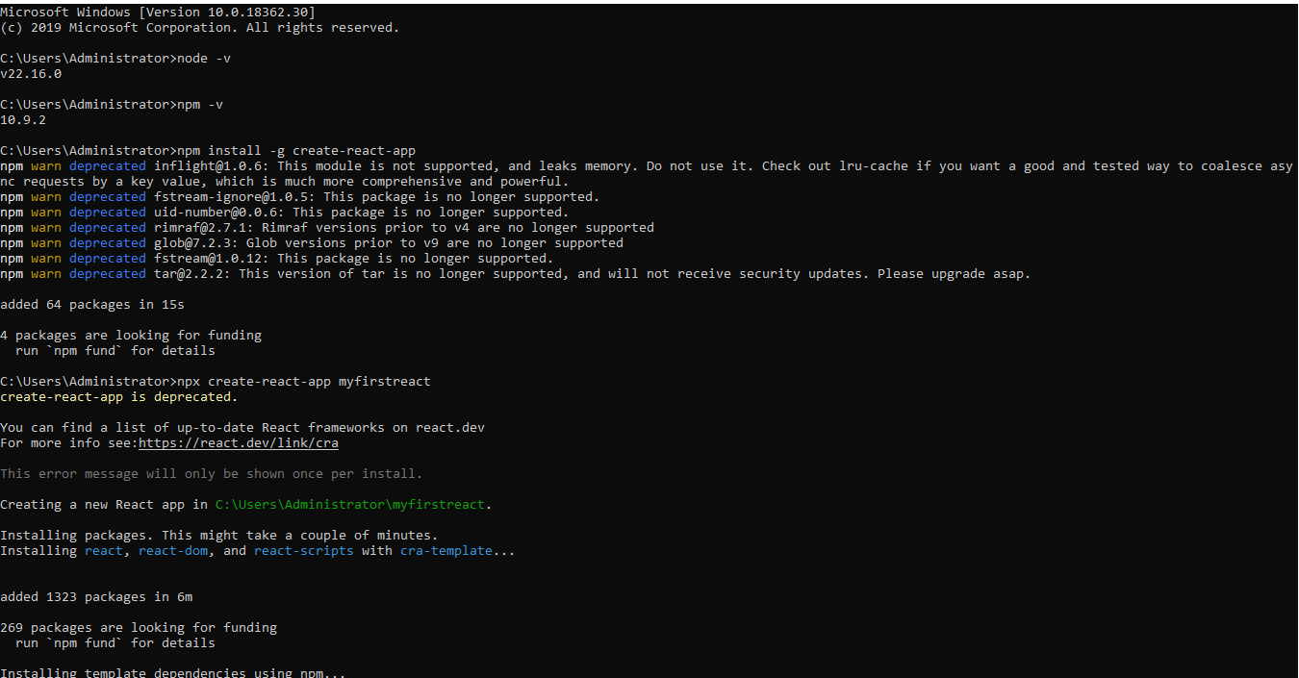

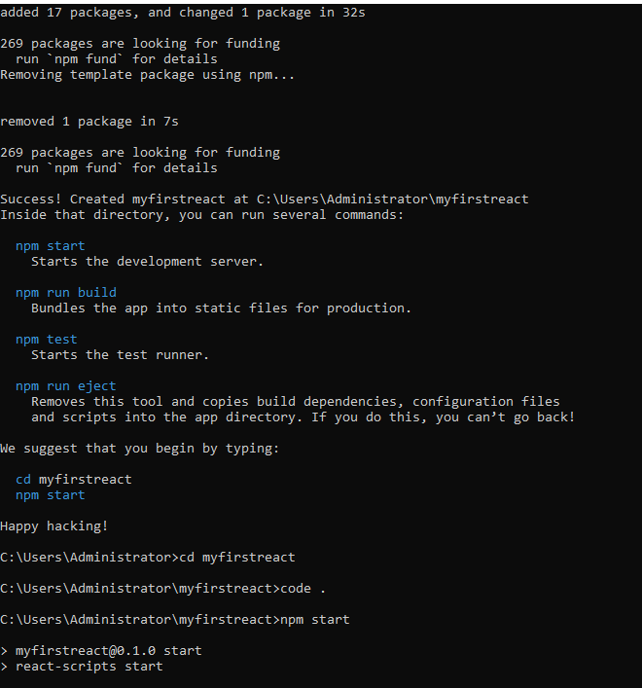

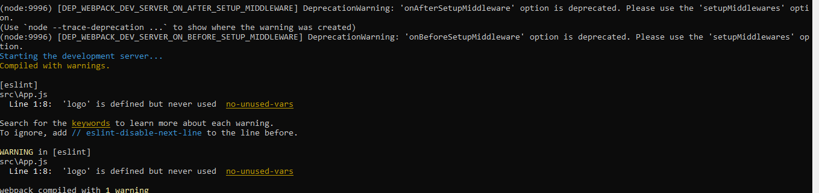

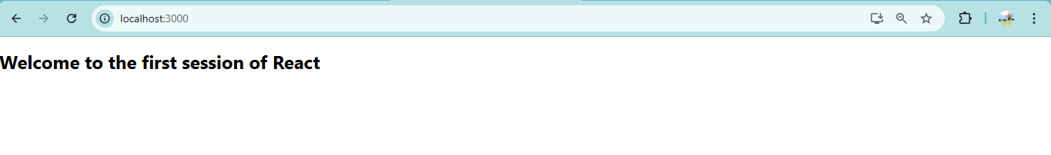

**Docs 2**

**Create a react app for Student Management Portal named StudentApp and create a component named Home which will display the Message “Welcome to the Home page of Student Management Portal”. Create another component named About and display the Message “Welcome to the About page of the Student Management Portal”. Create a third component named Contact and display the Message “Welcome to the Contact page of the Student Management Portal”. Call all the three components.**

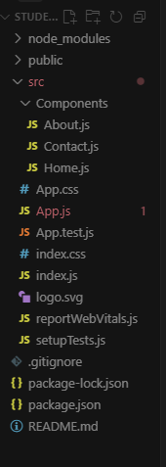

**Home.js**

import React from 'react';

function **Home**() {

return (

<div>

<h2>Welcome to the Home page of Student Management Portal</h2>

</div>

);

}

export default Home;

**About.js**

import React from 'react';

function **About**() {

return (

<div>

<h2>Welcome to the About page of Student Management Portal</h2>

</div>

);

}

export default About;

**App.js**

import logo from './logo.svg';

import './App.css';

import React from 'react';

import Home from './Components/Home';

import About from './Components/About';

import Contact from './Components/Contact';

function **App**() {

return (

<div>

<Home />

<About />

<Contact />

</div>

);

}

export default App;

**Output:**

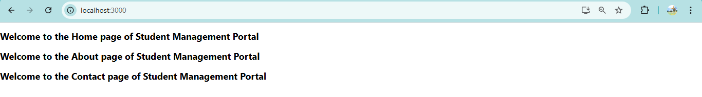

**Docs 3**

**Create a react app for Student Management Portal named scorecalculatorapp and create a function component named “CalculateScore” which will accept Name, School, Total and goal in order to calculate the average score of a student and display the same.**

**CalculateScore.js**

import React from 'react';

import '../Stylesheets/mystyle.css';

function CalculateScore() {

const name = "Prabha";

const school = "ABC High School";

const total = 504;

const goal = 600;

const average = (total / goal) * 100;

return (

<div className="score-card">

<h2>Student Score Report</h2>

<p><strong>Name:</strong> {name}</p>

<p><strong>School:</strong> {school}</p>

<p><strong>Total Score:</strong> {total}</p>

<p><strong>Goal:</strong> {goal}</p>

<p><strong>Average Score:</strong> {average.toFixed(2)}%</p>

</div>

);

}

export default CalculateScore;

**Mystyle.css**

.score-card {

border: 2px solid #4CAF50;

padding: 20px;

margin: 30px auto;

width: 50%;

text-align: left;

background-color: #f0fff4;

font-family: Arial, sans-serif;

box-shadow: 2px 2px 10px rgba(0, 0, 0, 0.1);

}

.score-card h2 {

text-align: center;

color: #2e7d32;

}

.score-card p {

font-size: 18px;

margin: 5px 0;

}

**App.js**

import logo from './logo.svg';

import './App.css';

import React from 'react';

import CalculateScore from './Components/CalculateScore';

function App() {

return (

<div>

<CalculateScore />

</div>

);

}

export default App;

**Output:**

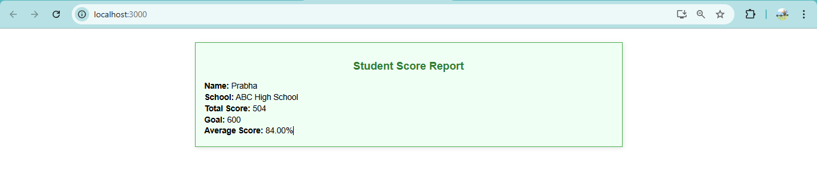

**Docs 4**

**Create a new react application using create-react-app tool with the name as “blogapp”**

**Post.js**

class Post {

constructor(userId, id, title, body) {

this.userId = userId;

this.id = id;

this.title = title;

this.body = body;

}

}

export default Post;

**Posts.js**

import React, { Component } from 'react';

import Post from './Post';

class Posts extends Component {

constructor(props) {

super(props);

this.state = {

posts: [],

hasError: false

};

}

loadPosts = () => {

fetch('https://jsonplaceholder.typicode.com/posts')

.then(response => response.json())

.then(data => {

const postList = data.slice(0, 5).map(

p => new Post(p.userId, p.id, p.title, p.body)

);

this.setState({ posts: postList });

})

.catch(error => {

console.error("Error fetching posts:", error);

this.setState({ hasError: true });

});

};

componentDidMount() {

this.loadPosts();

}

componentDidCatch(error, info) {

alert("An error occurred in Posts component.");

console.error("Error:", error, info);

}

render() {

const { posts, hasError } = this.state;

if (hasError) {

return <h3>Something went wrong while loading posts.</h3>;

}

return (

<div>

<h2>Recent Blog Posts</h2>

{posts.map(post => (

<div key={post.id} style={{ marginBottom: '20px' }}>

<h3>{post.title}</h3>

<p>{post.body}</p>

</div>

))}

</div>

);

}

}

export default Posts;

**App.js**

import logo from './logo.svg';

import './App.css';

import React from 'react';

import Posts from './Posts';

function App() {

return (

<div className="App">

<Posts />

</div>

);

}

export default App;

**Output:**

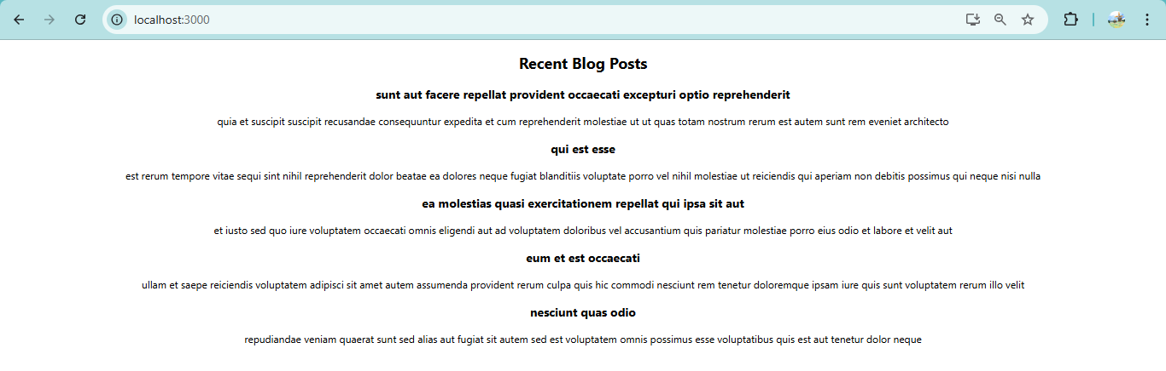

**Docs 5**

**My Academy team at Cognizant want to create a dashboard containing the details of ongoing and completed cohorts.**

**CohortDetails.js**

import React from 'react';

import styles from './CohortDetails.module.css';

function CohortDetails({ cohort }) {

const headingStyle = {

color: cohort.status === 'ongoing' ? 'blue' : 'green'

};

return (

<div className={styles.box}>

<h3 style={headingStyle}>{cohort.name}</h3>

<dl>

<dt>Status:</dt>

<dd>{cohort.status}</dd>

<dt>Start Date:</dt>

<dd>{cohort.startDate}</dd>

<dt>End Date:</dt>

<dd>{cohort.endDate}</dd>

</dl>

</div>

);

}

export default CohortDetails;

**CohortDetails.module.css**

.box {

width: 300px;

display: inline-block;

margin: 10px;

padding: 10px 20px;

border: 1px solid black;

border-radius: 10px;

}

dt {

font-weight: 500;

}

**App.js**

import logo from './logo.svg';

import './App.css';

import React from 'react';

import CohortDetails from './components/CohortDetails';

function App() {

const cohorts = [

{ name: 'React Bootcamp', status: 'ongoing', startDate: '2025-08-01', endDate: '2025-09-01' },

{ name: 'Java Spring Mastery', status: 'completed', startDate: '2025-06-01', endDate: '2025-07-01' },

{ name: 'Python', status: 'completed', startDate: '2025-04-01', endDate: '2025-06-01' }

];

return (

<div>

{cohorts.map((cohort, index) => (

<CohortDetails key={index} cohort={cohort} />

))}

</div>

);

}

export default App;

**Output:**

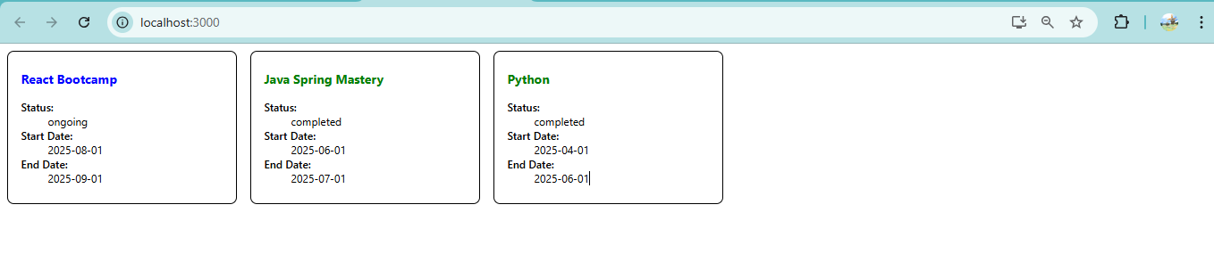

**Docs 6**

**Cognizant Academy teams want to maintain a list of trainers along with their expertise in a SPA using React as the technology. You are assigned the task of creating this React app.**

**Home.js**

import React from 'react';

function Home() {

return (

<div>

<h2>Welcome to Cognizant Academy Trainer Portal</h2>

<p>Navigate to trainers to explore trainer profiles.</p>

</div>

);

}

export default Home;

**App.js**

import logo from './logo.svg';

import './App.css';

import React from 'react';

import { BrowserRouter, Routes, Route, Link } from 'react-router-dom';

import Home from './Home';

import TrainerList from './TrainerList';

import TrainerDetails from './TrainerDetails';

import trainers from './TrainersMock';

function App() {

return (

<BrowserRouter>

<div>

<h1>Trainers Portal</h1>

<nav>

<Link to="/">Home</Link> |{" "}

<Link to="/trainers">Trainers</Link>

</nav>

<hr />

<Routes>

<Route path="/" element={<Home />} />

<Route path="/trainers" element={<TrainerList trainers={trainers} />} />

<Route path="/trainer/:id" element={<TrainerDetails />} />

</Routes>

</div>

</BrowserRouter>

);

}

export default App;

**TrainerList.js**

import React from 'react';

import { Link } from 'react-router-dom';

function TrainerList({ trainers }) {

return (

<div>

<h2>Trainer List</h2>

<ul>

{trainers.map(trainer => (

<li key={trainer.TrainerId}>

<Link to={`/trainer/${trainer.TrainerId}`}>{trainer.Name}</Link>

</li>

))}

</ul>

</div>

);

}

export default TrainerList;

**TrainersMock.js**

import Trainer from './Trainer';

const trainers = [

new Trainer(1, "Prabha", "[prabha@example.com](mailto:prabha@example.com)", "9876543210", "React", "JS, JSX, Hooks"),

new Trainer(2, "Karthick", "[karthick@example.com](mailto:karthick@example.com)", "9876500001", "Java", "Spring, Hibernate"),

new Trainer(3, "Poovi", "[poovi@example.com](mailto:poovi@example.com)", "9876512345", "Python", "Django, Flask")

];

export default trainers;

**Trainer.js**

class Trainer {

constructor(id, name, email, phone, technology, skills) {

this.TrainerId = id;

this.Name = name;

this.Email = email;

this.Phone = phone;

this.Technology = technology;

this.Skills = skills;

}

}

export default Trainer;

**TrainerDetails.js**

import React from 'react';

import { useParams } from 'react-router-dom';

import trainers from './TrainersMock';

function TrainerDetails() {

const { id } = useParams();

const trainer = trainers.find(t => t.TrainerId.toString() === id);

if (!trainer) return <h3>Trainer not found</h3>;

return (

<div>

<h2>Trainer Details</h2>

<p><strong>Name:</strong> {trainer.Name}</p>

<p><strong>Email:</strong> {trainer.Email}</p>

<p><strong>Phone:</strong> {trainer.Phone}</p>

<p><strong>Technology:</strong> {trainer.Technology}</p>

<p><strong>Skills:</strong> {trainer.Skills}</p>

</div>

);

}

export default TrainerDetails;

**(OR)**

import React from 'react';

import { useParams } from 'react-router-dom';

import trainers from './TrainersMock';

function TrainerDetails() {

const { id } = useParams();

const trainer = trainers.find(t => t.TrainerId.toString() === id);

if (!trainer) return <h3>Trainer not found</h3>;

const skillList = trainer.Skills.split(',').map(skill => skill.trim());

return (

<div>

<h3>Trainers Details</h3>

<p><strong>{trainer.Name}</strong></p>

<p>{trainer.Email}</p>

<p>{trainer.Phone}</p>

<ul>

{skillList.map((skill, index) => (

<li key={index}>{skill}</li>

))}

</ul>

</div>

);

}

export default TrainerDetails;

**Output:**

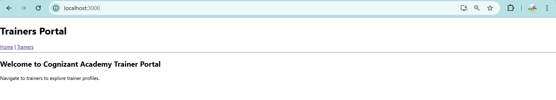

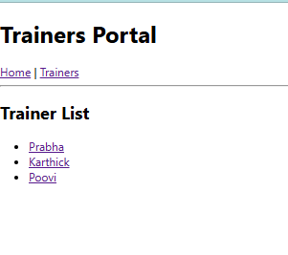

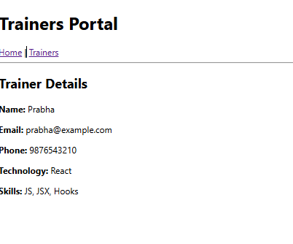

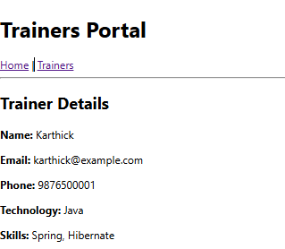

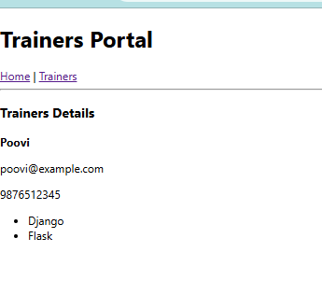

**Docs 7**

**Create a React Application named “shoppingapp” with a class component named “OnlineShopping” and “Cart”.**

**Cart.js**

import React, { Component } from 'react';

class Cart extends Component {

render() {

return (

<tr>

<td>{this.props.itemname}</td>

<td>{this.props.price}</td>

</tr>

);

}

}

Cart.defaultProps = {

itemname: "Unknown",

price: "0"

};

export default Cart;

**OnlineShopping.js**

import React, { Component } from 'react';

import Cart from './Cart';

import './ShoppingStyle.css';

class OnlineShopping extends Component {

render() {

const items = [

{ itemname: 'Laptop', price: 80000 },

{ itemname: 'TV', price: 120000 },

{ itemname: 'Washing Machine', price: 50000 },

{ itemname: 'Mobile', price: 30000 },

{ itemname: 'Fridge', price: 70000 }

];

return (

<div className="container">

<h2 className="title">Items Ordered :</h2>

<table className="item-table">

<thead>

<tr>

<th>Name</th>

<th>Price</th>

</tr>

</thead>

<tbody>

{items.map((item, index) => (

<Cart key={index} itemname={item.itemname} price={item.price} />

))}

</tbody>

</table>

</div>

);

}

}

export default OnlineShopping;

**ShoppingStyle.js**

.container {

text-align: center;

margin-top: 30px;

}

.title {

color: green;

font-weight: bold;

font-size: 24px;

}

.item-table {

margin: 0 auto;

border-collapse: collapse;

width: 300px;

font-family: Arial, sans-serif;

}

.item-table th,

.item-table td {

border: 1px solid #888;

padding: 10px;

color: green;

font-weight: bold;

}

.item-table th {

background-color: #f2f2f2;

}

**Index.js**

import React from 'react';

import { createRoot } from 'react-dom/client';

import OnlineShopping from './OnlineShopping';

const root = createRoot(document.getElementById('root'));

root.render(<OnlineShopping />);

**Output:**

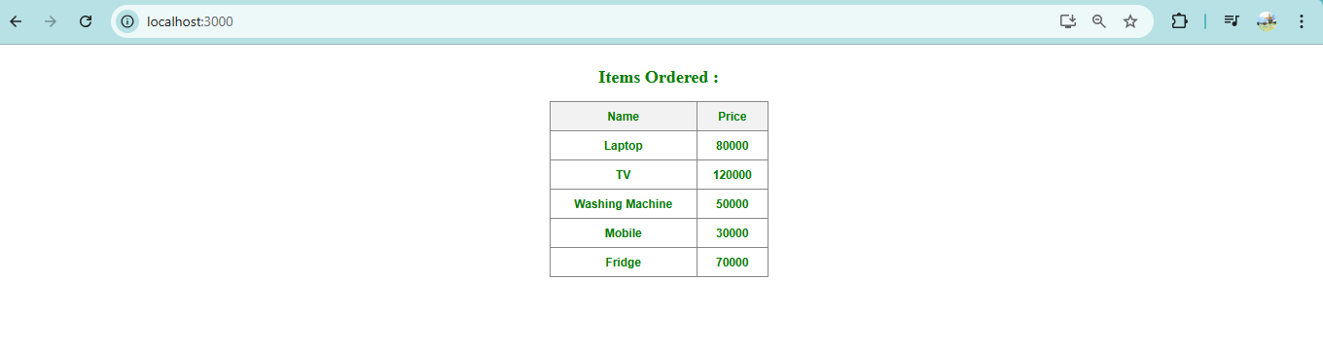

**Docs 8**

**Create a React App “counterapp” which will have a component named “CountPeople” which will have 2 methods.**

**CountPeople.js**

import React, { Component } from 'react';

import './CounterStyle.css';

class CountPeople extends Component {

constructor(props) {

super(props);

this.state = {

entryCount: 0,

exitCount: 0

};

}

updateEntry = () => {

this.setState(prevState => ({

entryCount: prevState.entryCount + 1

}));

};

updateExit = () => {

this.setState(prevState => ({

exitCount: prevState.exitCount + 1

}));

};

render() {

return (

<div className="count-wrapper">

<div className="count-box">

<button className="btn" onClick={this.updateEntry}>Login</button>

<span>{this.state.entryCount} People Entered!!!</span>

</div>

<div className="count-box">

<button className="btn" onClick={this.updateExit}>Exit</button>

<span>{this.state.exitCount} People Left!!!</span>

</div>

</div>

);

}

}

export default CountPeople;

**App.js**

import logo from './logo.svg';

import './App.css';

import React from 'react';

import CountPeople from './CountPeople';

function App() {

return (

<div className="App">

<CountPeople />

</div>

);

}

export default App;

**CounterStyle.js**

.count-wrapper {

display: flex;

justify-content: space-around;

align-items: center;

margin-top: 100px;

font-family: Arial, sans-serif;

}

.count-box {

display: flex;

align-items: center;

gap: 10px;

}

.btn {

padding: 10px 20px;

background-color: green;

color: white;

border: none;

font-weight: bold;

border-radius: 4px;

cursor: pointer;

}

.btn:hover {

background-color: darkgreen;

}

span {

font-size: 18px;

}

**Output:**

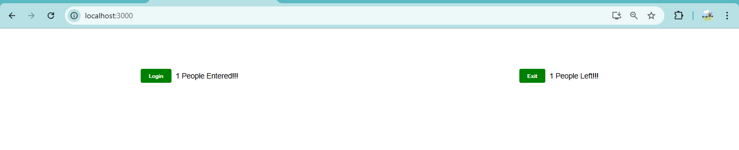

**Docs 9**

**Create a React Application named “cricketapp”**

**App.js**

import logo from './logo.svg';

import './App.css';

import React from "react";

import ListOfPlayers from "./components/ListOfPlayers";

import IndianPlayers from "./components/IndianPlayers";

function App(){

const flag = true;

return (

<div className="App">

<h1>CricketApp — demo</h1>

{flag ? <ListOfPlayers /> : <IndianPlayers />}

{}

</div>

);

}

export default App;

**IndianPlayers.js**

// src/components/IndianPlayers.jsx

import React from "react";

export default function IndianPlayers() {

const players = [

"Player1","Player2","Player3","Player4","Player5",

"Player6","Player7","Player8","Player9","Player10","Player11"

];

const [firstPlayer, secondPlayer, ...rest] = players;

const oddTeam = players.filter((_, idx) => idx % 2 === 0);

const evenTeam = players.filter((_, idx) => idx % 2 !== 0);

const T20players = ["T20-A","T20-B"];

const RanjiTrophy = ["Ranji-A","Ranji-B"];

const merged = [...T20players, ...RanjiTrophy];

return (

<div>

<h2>Destructured highlights</h2>

<p>First: {firstPlayer}, Second: {secondPlayer}</p>

<h3>Odd Team</h3>

<ul>{oddTeam.map((p,i) => <li key={i}>{p}</li>)}</ul>

<h3>Even Team</h3>

<ul>{evenTeam.map((p,i) => <li key={i}>{p}</li>)}</ul>

<h3>Merged squads</h3>

<ul>{merged.map((p,i) => <li key={i}>{p}</li>)}</ul>

</div>

);

}

**ListOfPlayers.js**

import React from "react";

export default function ListOfPlayers() {

const players = [

{ name: "Mr. Dhoni", score: 85 },

{ name: "Mr. Ruturaj", score: 74 },

{ name: "Mr. Jadeja", score: 64 },

{ name: "Mr. Dube", score: 58 },

{ name: "Mr. Rahane", score: 45 },

{ name: "Mr. Conway", score: 90 },

{ name: "Mr. Moeen Ali", score: 66 },

{ name: "Mr. Santner", score: 39 },

{ name: "Mr. Chahar", score: 25 },

{ name: "Mr. Gaikwad", score: 72 },

{ name: "Mr. Stokes", score: 50 },

];

const allPlayersList = players.map((p, i) => (

<li key={i}>{p.name} {p.score}</li>

));

const below70 = players.filter(p => p.score < 70);

return (

<div>

<h2>List of Players</h2>

<ul>{allPlayersList}</ul>

<hr />

<h2>List of Players having Scores Less than 70</h2>

<ul>

{below70.map((p, i) => (

<li key={i}>{p.name} {p.score}</li>

))}

</ul>

</div>

);

}

**Output:**

